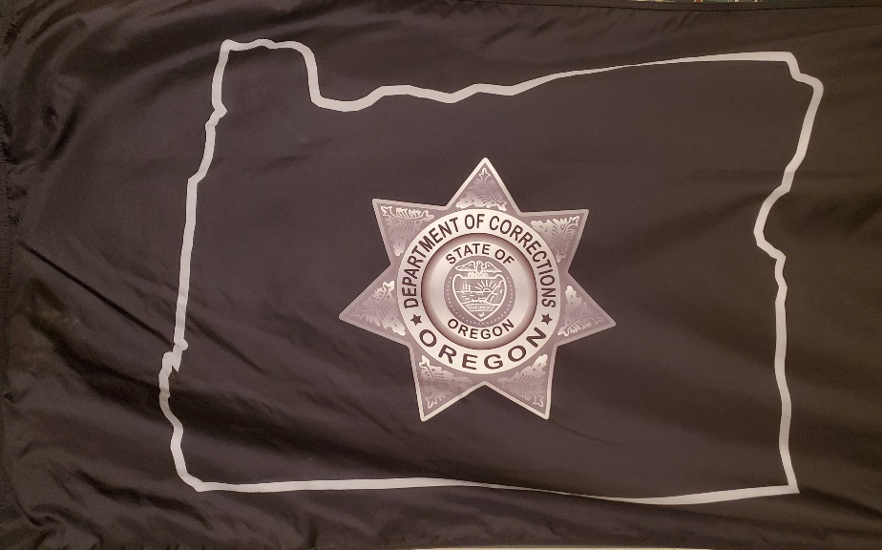
December 14, 2020
REMARKS FOR THE 2020
CORRECTIONAL ADMINISTRATORS
MICHAEL FRANCKE AWARD

LET ME BEGIN BY THANKING JILL STEWART AND MY ITCHY BROTHER KEVIN FOR HELPING ME GET THIS VIDEO COMPLETED AND PRESENTED TO THE ASSOCIATION.
PLEASE LET ME THANK ALL OF YOU FOR INVITING ME TO BE PART OF THE MICHAEL FRANCKE ACHIEVEMENT OF EXCELLENCE AWARD PRESENTATION OVER THE PAST SEVERAL YEARS.
THIS YEAR’S RECIPIENT, COLETTE PETERS OF OREGON, IS ESPECIALLY DESERVING. SINCE 2012 SHE HAS DIRECTED THE DEPARTMENT THAT MIKE WAS RUNNING AT THE TIME OF HIS MURDER; AND HAS DONE AN EXCELLENT JOB BY ALL STANDARDS.
ON A MORE PERSONAL NOTE, I MET HER AT THE DINNER SEVERAL YEARS AGO. I WAS IMPRESSED WITH HER INTELLIGENCE AND PROFESSIONAL, KIND AND GRACIOUS MANNER. SHE SPOKE OF MIKE’S WORK, KNEW OF HIS CONTRIBUTIONS IN OREGON IN THE TWO YEARS HE WAS THERE, AND SENT WISHES TO OUR FAMILY.
I MENTIONED TO HER THAT THE TREE PLANTED BY THE OREGON D.O.C. STAFF ON THE ONE YEAR ANNIVERSARY OF HIS MURDER HAD BEEN “HAREVESTED” AT CHRISTMAS.
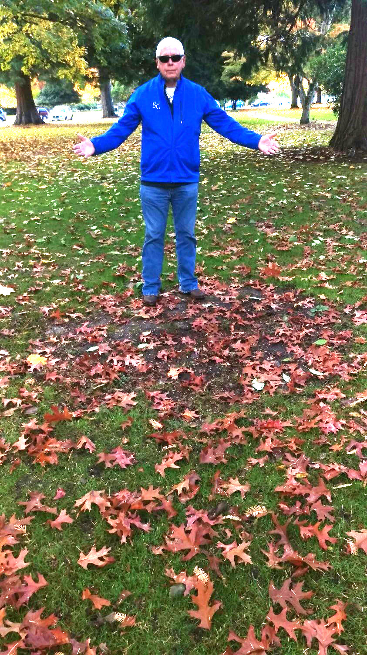
WE WERE SOON NOTIFIED THAT THE TREE HAD BEEN REPLACED IN A NEW LOCATION NEAR THE OREGON SUPREME COURT. I HAVE VISITED IT MANY TIMES, AND MY BROTHER KEVIN, WHO LIVES IN SALEM, GOES THERE OFTEN TO WALK HIS DOG.
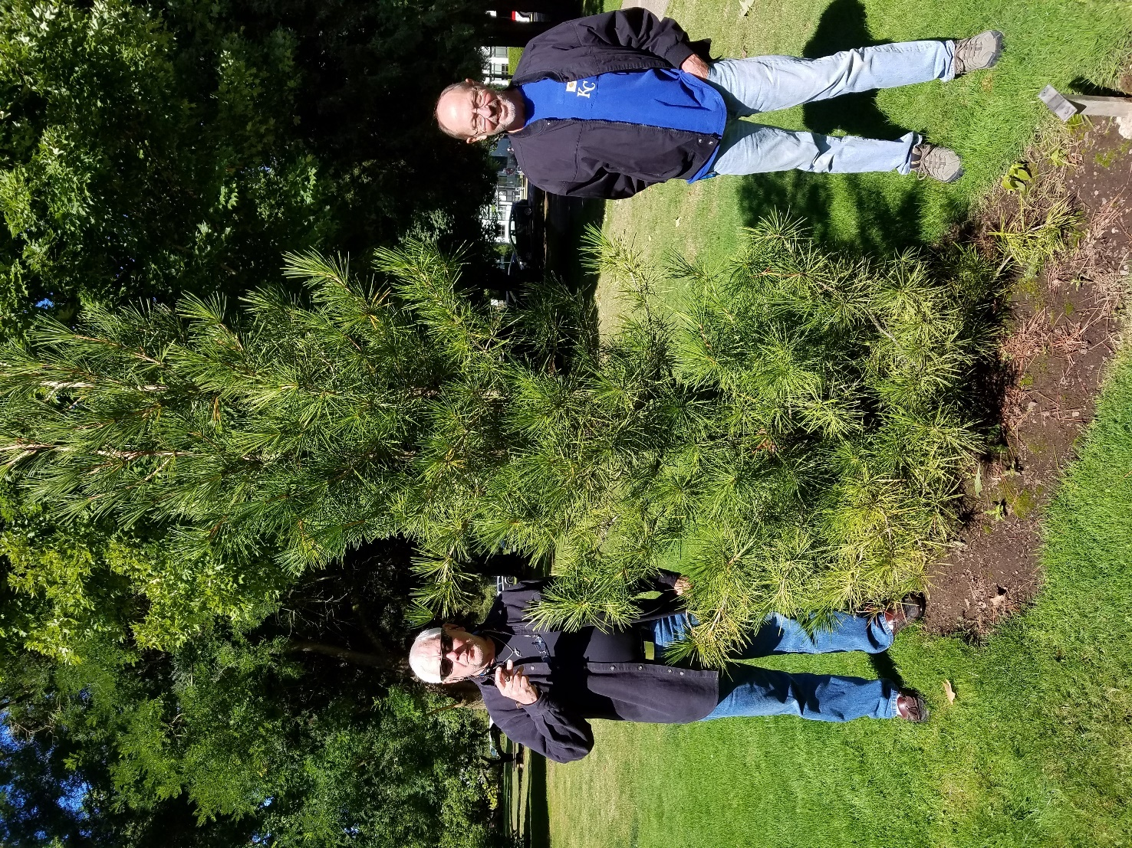

ON THE ANNIVERSARY OF MIKE’S DEATH KEVIN AND I HAD GONE TO THE SPOT ON THE PORCH AT CORRECTIONS WHER MIKE DIED TO PLACE CANDLES AND FLOWERS. COLLETTE ASKED US TO PLEASE REFRAIN AS IT UPSET SEVERAL OF HER STAFF. UNDERSTOOD.
COLETTE WENT TO WORK. THEY WERE MODERNIZING THEIR MAIN CONFERENCE ROOM AT HEADQUARTERS. THE ROOM WAS NAMED THE MICHAEL FRANCKE CONFERENCE ROOM. WE WERE INVITED TO THE DEDICATION CEREMONY ON JANUARY 16, 2015 AND WERE OVERWHELMED BY THE SCOPE OF THE WORK. THE SHADOW BOX ON THE WALL IS A MOVING TESTIMONY TO THE HISTORY OF CORRECTIONS IN OREGON AND TO MIKE FRANCKE.
SHE ALSO HAD HER PEOPLE COMMISSION A MEMORIAL. IT WAS DESIGNED AND CONSTRUCTED BY INMATES AND PLACED OUTSIDE AT THE BOTTOM OF THE STAIRS TO THAT PORCH ALONG WITH A BENCH. THEY ARE IMPRESSIVE PIECES OF METAL ART.
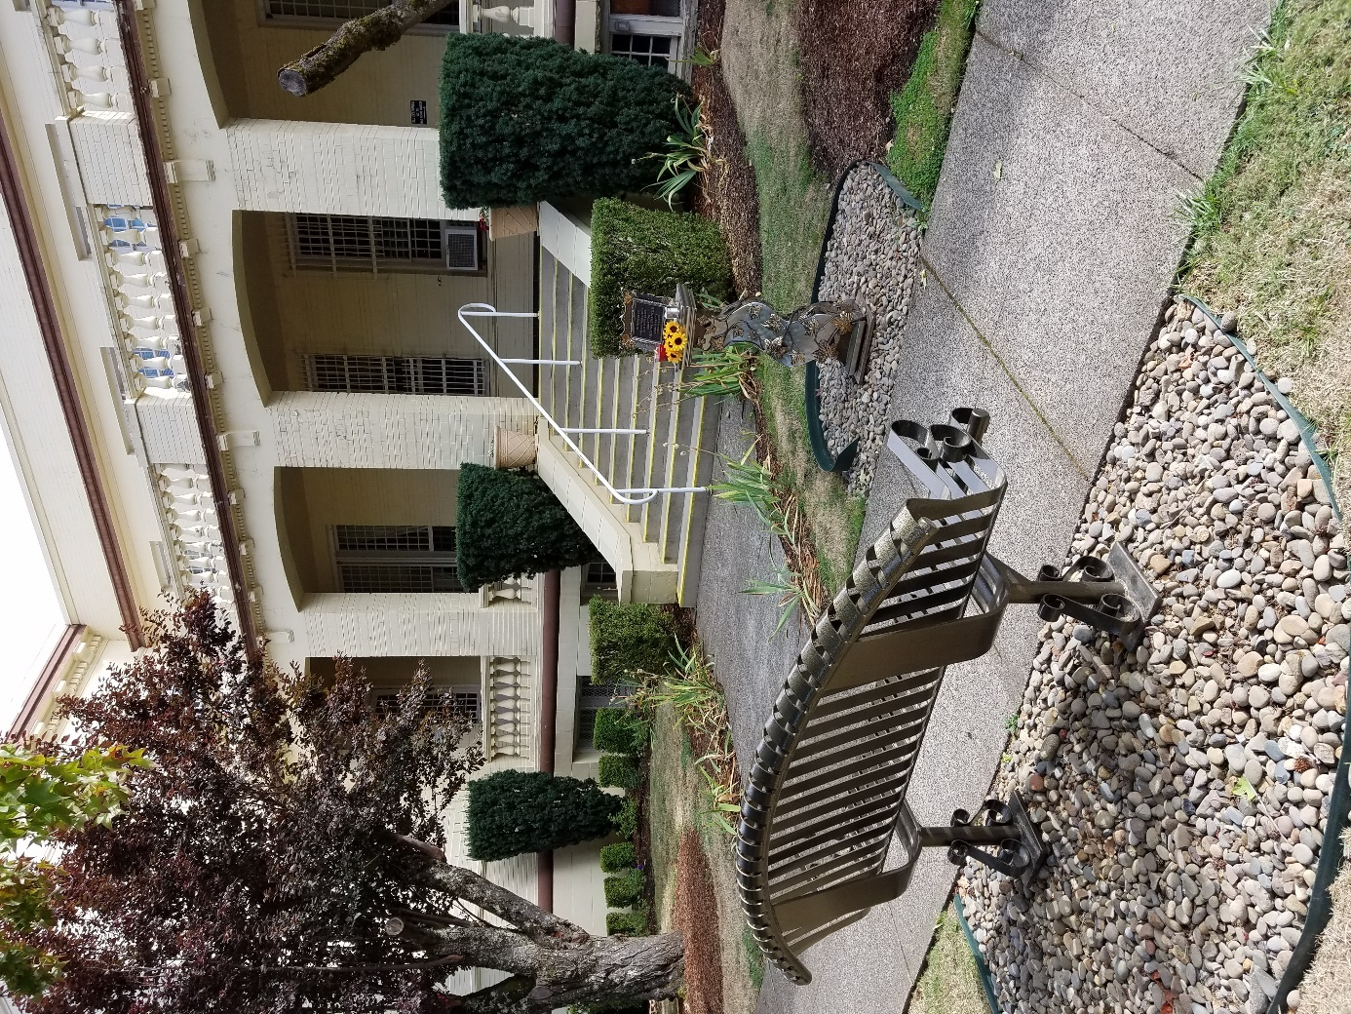
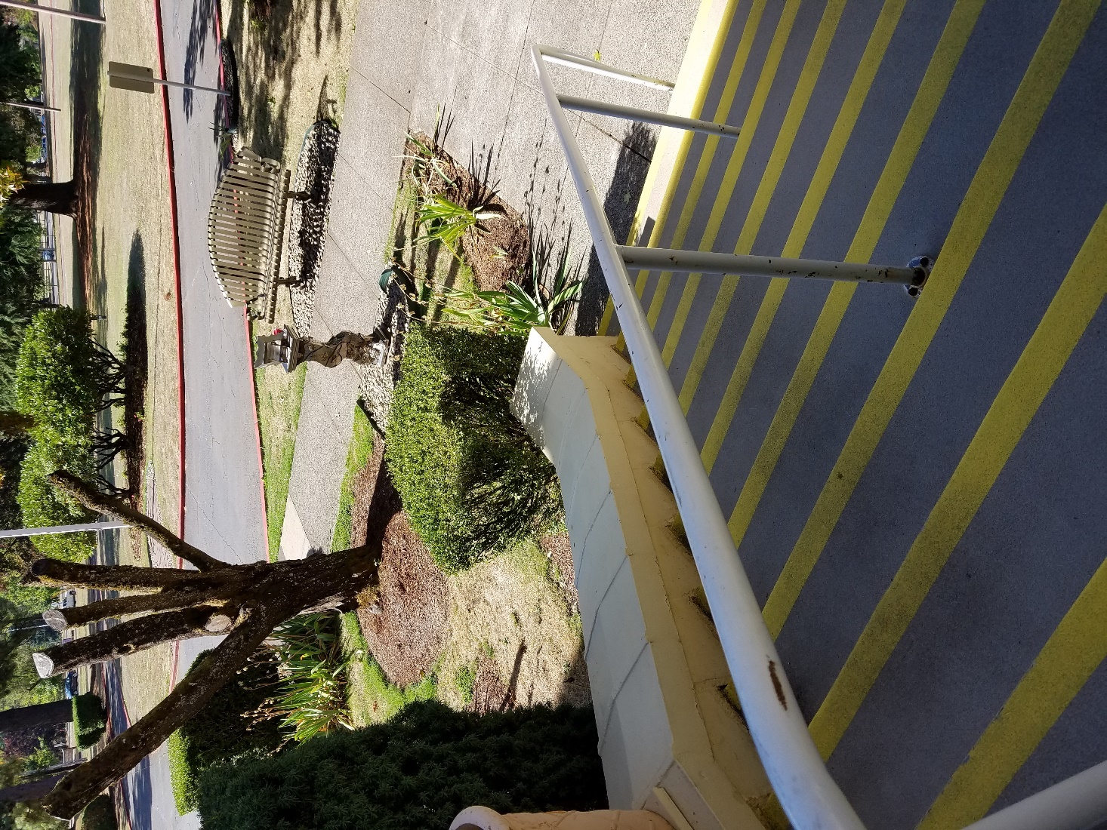
MY FAMILY AND FRIENDS HAVE SAT AND PRAYED THERE OFTEN OVER THE YEARS. THERE HAVE BEEN SEVERAL BUDWEISERS TIPPED THERE OVER TIME.
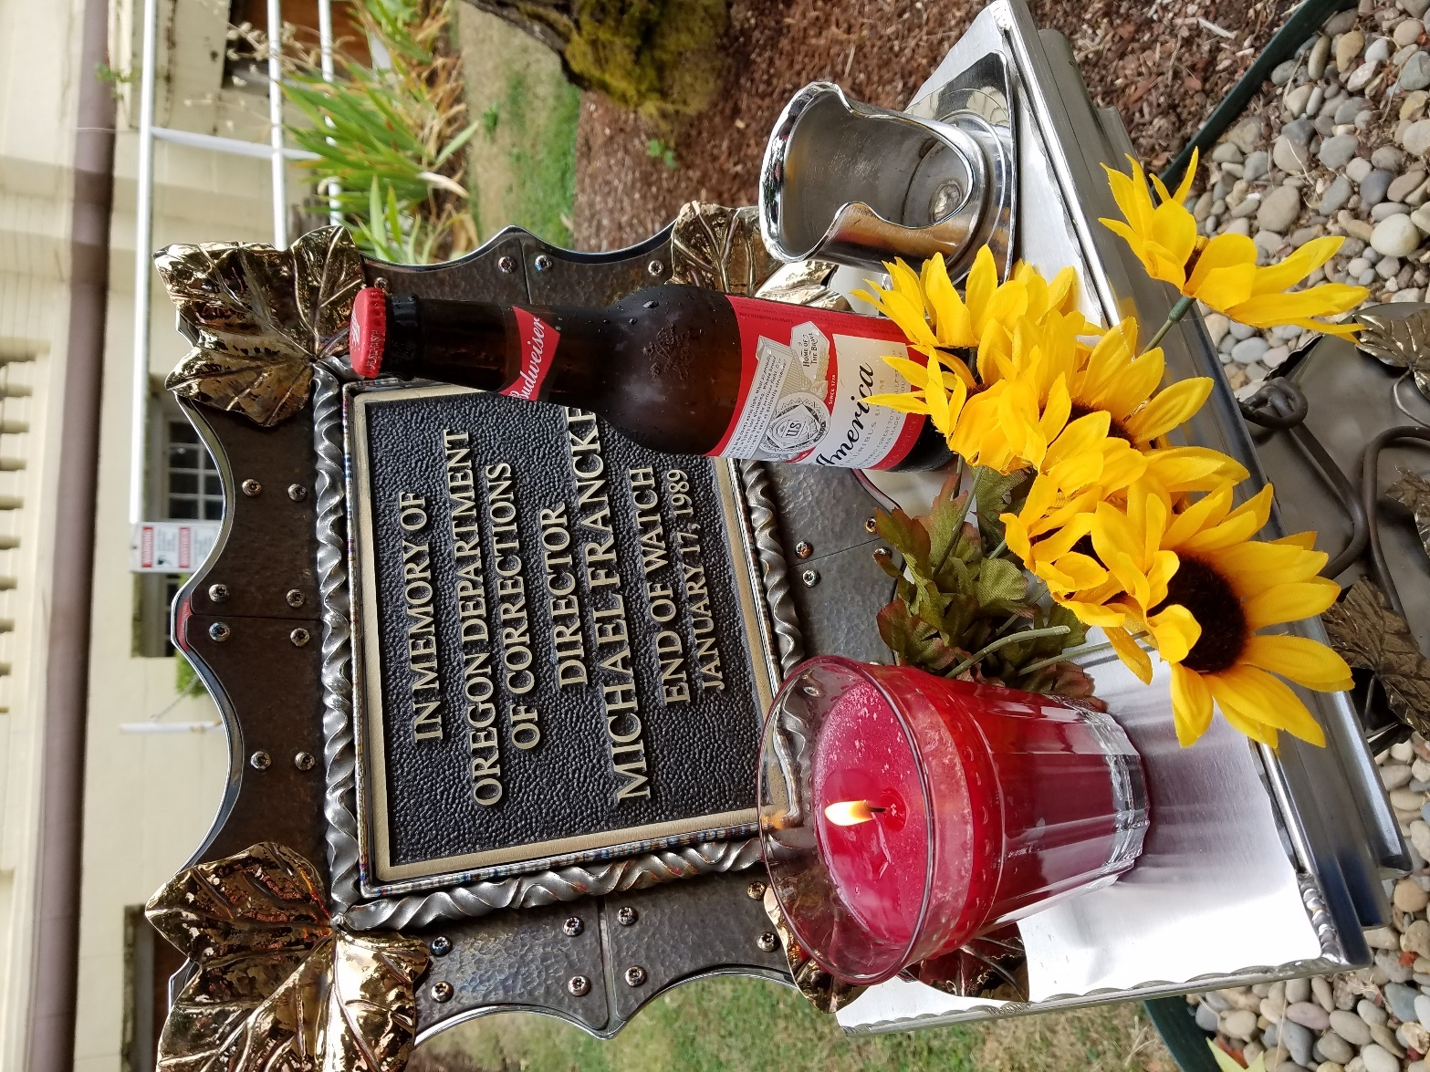
GOD BLESS HER AND EVERYONE CONNECTED TO THE PROJECT.
I HAVE HERE MIKE’S COPY OF THE HANDBOOK THAT HE HAD MADE FOR HIS STAFF IN NEW MEXICO. WHEN HE MOVED TO OREGON, HE GAVE IT TO HIS FRIEND AND LAWYER, DEPUTY AG JOHN BIGELOW. THEY HAD WORKED CLOSELY TOGETHER DURING THE TIME BOTH THE FEDERAL GOVERNMENT AND THE STATE LEGISLATURE WERE TRYING TO PUT MIKE IN JAIL. THE FORMER BECAUSE THE STATE WAS NOT IN COMPLIANCE. THE LATTER BECAUSE MIKE WAS EXCEEDING HIS BUDGET. SOUND FAMILIAR?
I RECENTLY HAD LUNCH IN SANTA FE WITH JOHN AND HIS WIFE. HE PRESENTED THIS TO ME. IT IS FILLED WITH MIKE’S HAND WRITTEN NOTES AND HIGHLIGHTED SECTIONS. THERE ARE A FEW HERE FOR YOU TO SEE.
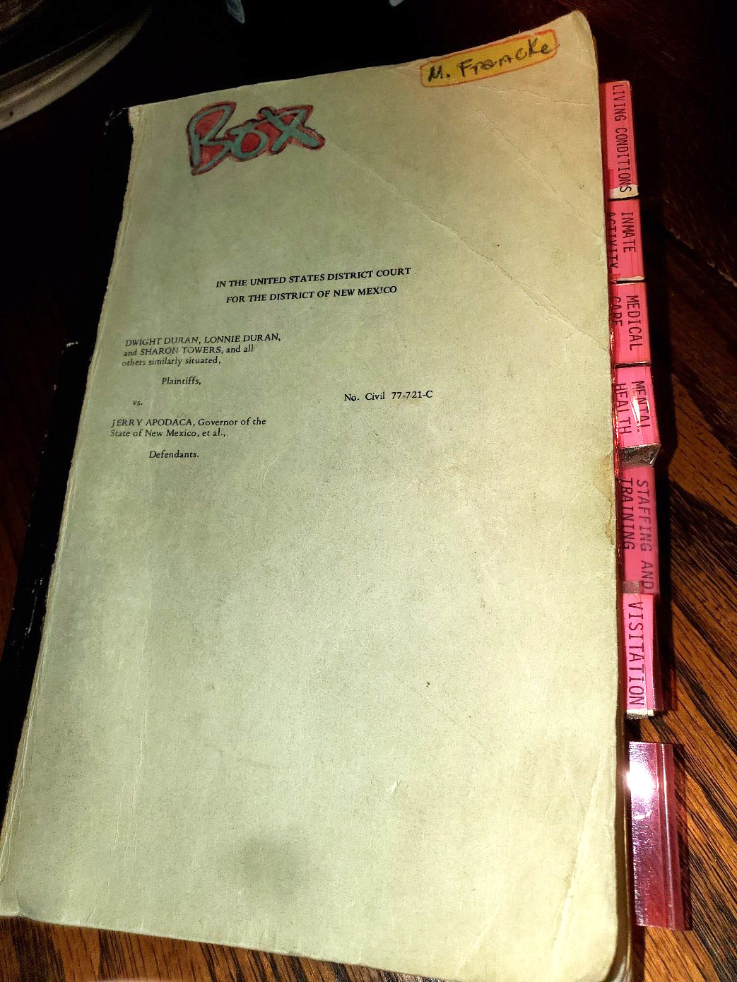
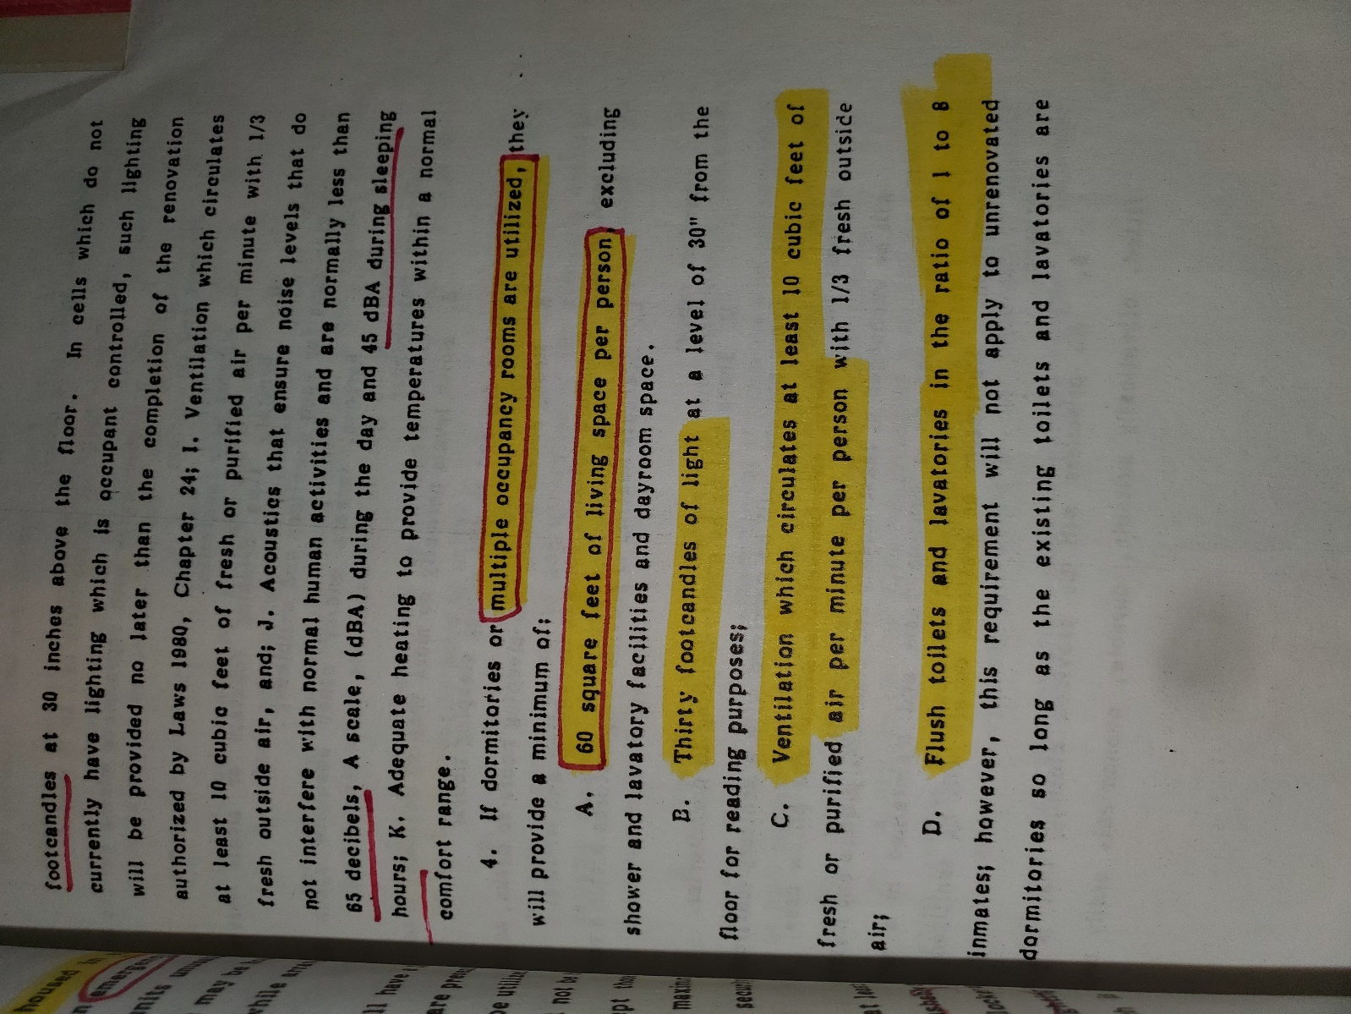
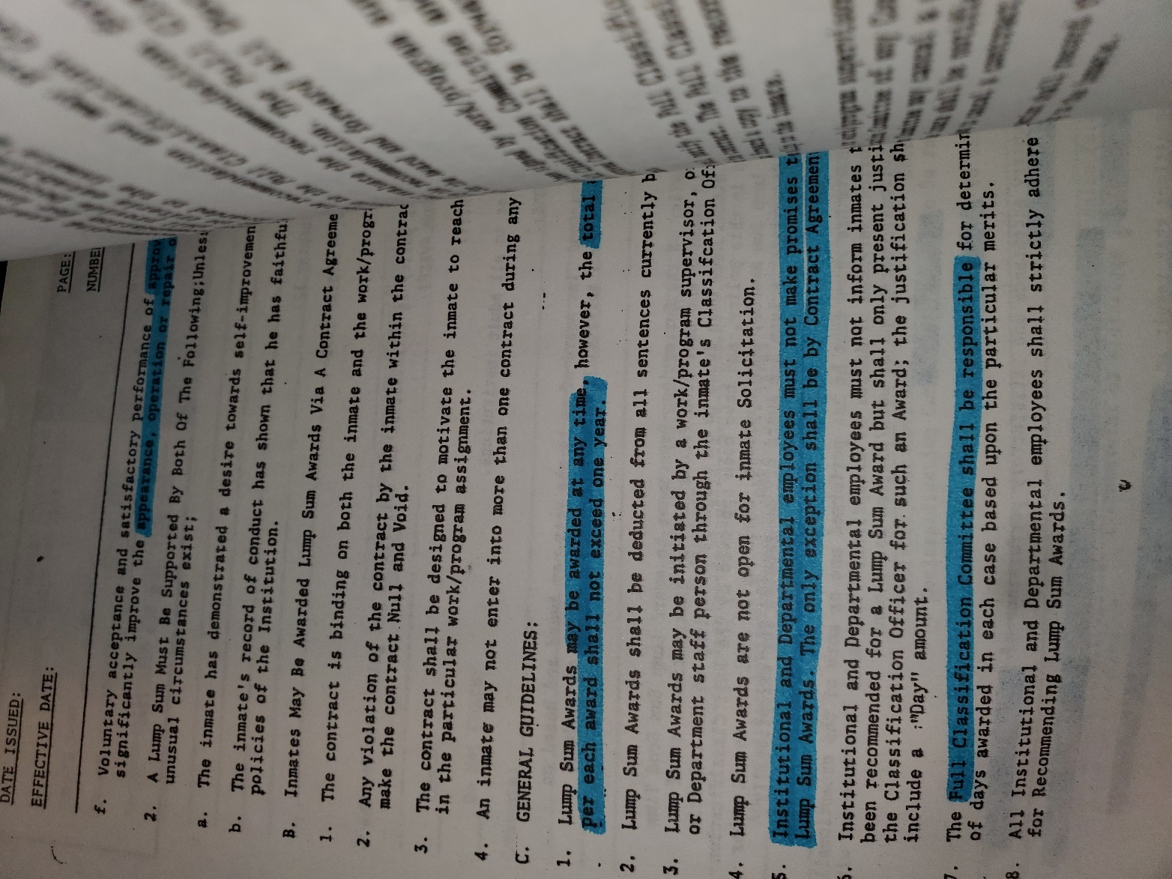
SEVERAL YEARS AGO, I GAVE GEORGE CAMP A COPY OF A SPEECH ON THECURRENT STATE OF THE OREGON SYSTEM. MIKE DELIVERED IT TO THE PORTLAND CITY CLUB, AN ORGANIZATION OF BUSINESS LEADERS. MOST OF HIS POINTS ARE RELEVANT TODAY AND I ENCOURAGE YOU TO TAKE TIME TO WATCH. Video
AS I LEAVE YOU, I RAISE A TOAST TO COLETTE. CONGRATULATIONS AND THANK YOU. THANKS TOO TO EVERYONE IN YOUR INDUSTRY FOR ALL THE DIFFICULT AND THANKLESS WORK YOU DO KEEPING US ALL SAFER.
MERRY CHRISTMAS. GOD BLESS YOU ALL, AND GOD BLESS AMERICA.
